IBM Watson (AI)

A Project Report Submitted
for

Information Technology
By

Harshit Mishra
(Roll no. 16)

Under the guidance of
Mr. Praveen Kumar Joshi



EVER GREEN SENIOR SECONDARY SCHOOL
(GOVERNED BY EDUCATIONAL WELFARE SOCIETY)
TULARAMPUR - 263139, DISTRICT-NAINITAL
UTTARAKHAND, INDIA

OCTOBER, 2021
CERTIFICATE

This is to certify that the project entitled IBM Watson (AI) being submitted to Evergeen Senior Secondary School, Haldwani for the project work of INFORMATION TECHNOLOGY is a record of the work carried by Mr. Harshit Mishra under my guidance and supervision.

Date: Supervisor
MR PRAVEENJOSHI TGT COMPUTER
Ever Green Sr. Sec. School, Haldwani
Forwarded By:
MR. M.S. PARWAL
Principal
Ever Green Sr. Sec. School, Haldwani

ABSTRACT
- IBM (i.e. International Business Machines) Watson is AI for smarter business.
- IBM’s portfolio of business-ready tools, applications and solutions, designed to reduce the costs and hurdles of AI adoption while optimizing outcomes and responsible use of AI.
- Watson is an IBM supercomputer that combines artificial intelligence (AI) and sophisticated analytical software for optimal performance as a "question answering" machine. The supercomputer is named for IBM's founder, Thomas J. Watson.
- Watson helps organizations predict future outcomes, automate complex processes, and optimize employees' time.
- IBM Watson is being used in multiple places such as Health, Video Streaming and Hosting, Advertising, IT operations, etc.
- Artificial intelligence is a technology using which we can create intelligent systems that can simulate human intelligence.
- AI is being used in multiple places such as Siri, Google’s Alpha Go, AI in Chess playing, etc.

ACKNOWLEDGEMENTS
I would like to express my most sincere heartfelt gratitude and respect to my supervisor MR. PRAVEEN JOSHI, MR. Girish Pathak for suggesting the topic for my project work and for his excellent guidance, valuable suggestions and endless support throughout for preparing the report. I am greatly indebted to him for his constructive suggestions and criticism from time to time during the course of progress of my work.
I would like to express my gratitude and sincere thanks to Mr. M.S. Parwal, Principal of School, and entire faculty who has imparted considerable knowledge to me.
Finally, I express my deepest gratitude to my parents for their continuous encouragement, understanding and support.

Harshit Mishra

TABLE OF CONTENTS

Chapter | Topic | Page No.
 | CERTIFICATE | 2
 | ABSTRACT | 3
 | ACKNOWLEDEGMENT | 4
 | INDEX | 5
1. | INTRODUCTION
1.1 | What is IBM Watson | 6-7
1.2 | Use Of IBM Watson
2 | Artificial intelligence | 7-8
2.1 | Use of AI
3 | IBM Watson super computer | 8-9
4 | Watson in health | 10
5 | Watson Analytics | 11
6 | Watson let business , build AI application | 11-12

IBM Watson {artificial intelligence}
IBM Watson is AI for business. Watson helps organizations predict future outcomes, automate complex processes, and optimize employees' time.
- Watson was created as a question answering (QA) computing system that IBM built to apply advanced natural language processing, information retrieval, knowledge representation, automated reasoning, and machine learning technologies to the field of open domain question answering.
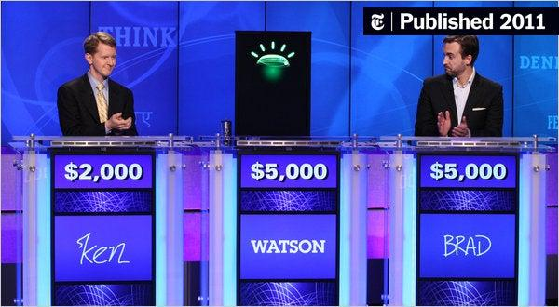

What is IBM and why is it important?

- IBM (International Business Machines) ranks among the world's largest information technology companies, providing a wide spectrum of hardware, software and services offerings.

IBM Watson mainly used in :
- Manufacturing, supply chain, human resources, customer service, marketing, advertising, building management, medicine, health sector, automotive, and agriculture

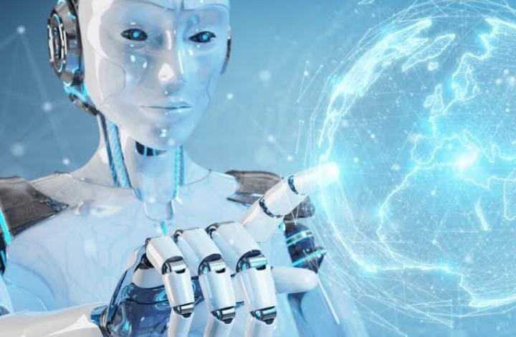

Artificial intelligence

It is a technology using which we can create intelligent systems that can simulate human intelligence. The Artificial intelligence system does not require to be pre-programmed, instead of that, they use such algorithms which can work with their own intelligence. It involves machine learning algorithms such as Reinforcement learning algorithm and deep learning neural networks. AI is being used in multiple places such as Siri, Google’s Alpha Go, AI in Chess playing, etc. Based on capabilities, AI can be classified into three types:
- Weak AI
- General AI
- Strong AI

- Use of AI in Following Fields:
- Virtual Assistant or Chatbots
- Agriculture and Farming
- Autonomous Flying
- Retail, Shopping and Fashion
- Security and Surveillance
- Sports Analytics and Activities
- Manufacturing and Production
- Live Stock and Inventory Management
- Self-driving Cars or Autonomous Vehicles
- Healthcare and Medical Imaging Analysis
- Warehousing and Logistic Supply Chain

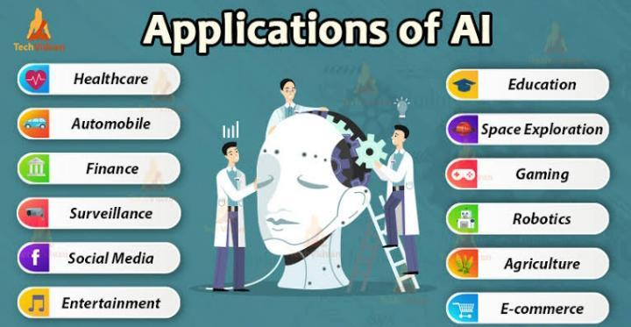

IBM Watson supercomputer
Watson is an IBM supercomputer that combines artificial intelligence and sophisticated analytical software for optimal performance as a "question answering" machine. The supercomputer is named for IBM's founder, Thomas J. Watson.
The Watson supercomputer processes at a rate of 80 teraflops (trillion floating point operations per second). To replicate (or surpass) a high-functioning human's ability to answer questions, Watson accesses 90 servers with a combined data store of over 200 million pages of information, which it processes against six million logic rules. The system and its data are self-contained in a space that could accommodate 10 refrigerators.
Watson's key components include:
- Apache Unstructured Information Management Architecture (UIMA) frameworks, infrastructure and other elements required for the analysis of unstructured data.
- Apache's Hadoop, a free, Java-based programming framework that supports the processing of large data sets in distributed computing environment.
- SUSE Enterprise Linux Server 11, the fastest available Power7 processor operating system.
- 2,880 processor cores.
- 15 terabytes (TB) of RAM.
- 500 gigabytes (GB) of preprocessed information.
- IBM's Deep QA software, which is designed for information retrieval that incorporates natural language processing (NLP) and machine learning
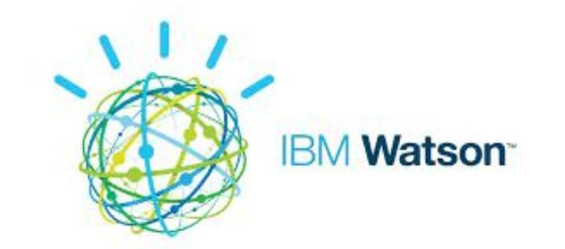

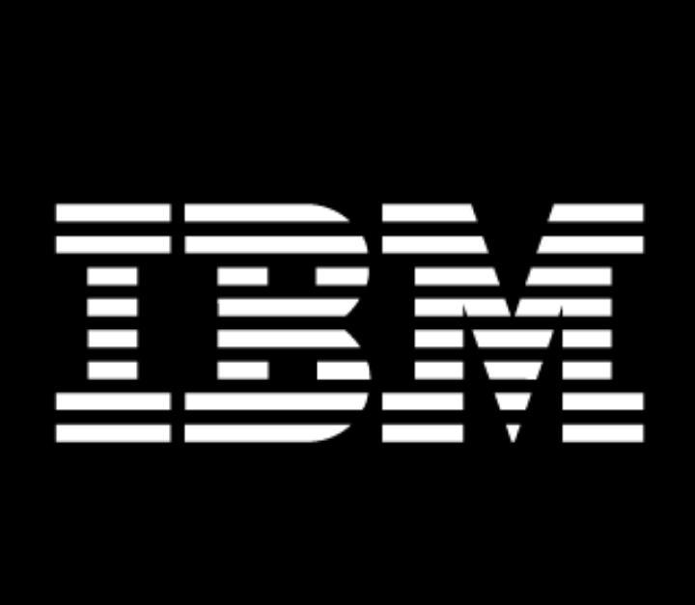

Watson in healthcare
Healthcare was one of the first industries to which Watson technology was applied. The first commercial implementation of Watson came in 2013 when the Memorial Sloan Kettering Cancer Center began using the system to recommend treatment options for lung cancer patients to ensure they received the right treatment while reducing costs. Since that time, providers such as Cleveland Clinic, Maine Center for Cancer Medicine and West med Medical Group have also implemented Watson tools.

Watson Analytics
Watson Analytics is one of the primary implementations of Watson technology. It is a platform for exploring, visualizing and presenting data that utilizes Watson's cognitive capabilities to automatically surface data-driven insights and recommend ways of presenting the data.
The platform is made up of an exploration component, which allows users to upload their data, automatically recommends potentially correlated variables and builds comparisons; a prediction tool that allows users to get answers to complex questions based on their data; and a reporting tool that supports dashboard and report development.
Each component is accessed using a graphical user interface (GUI), which minimizes the need for advanced data science training. The platform is intended to make advanced analytics accessible to workers with limited technical knowledge. The cost of Watson Analytics depends on the version; there is a free version which includes the ability to upload spreadsheets, get visualizations, get insights and build dashboards. The "Plus" edition includes the capabilities in the free version along with 2 GB of storage and data sources, including databases, starts at $30 per user, per month. A "Professional" edition with all of the above features, as well as a multiuser tenant to collaborate, 100 GB of storage and more data, costs $80 or more per user, per month. (2018 pricing sourced from IBM Watson Analytics website).

Watson APIs let businesses build AI applications
IBM has published a range of application program interfaces (APIs) on its cloud that allow users to build their own AI applications that utilize Watson's core technology on the back end. There are APIs that support popular development frameworks like Java, Python and others.

Summary

IBM Watson is a data analytics processor that uses natural language processing, a technology that analyzes human speech for meaning and syntax. IBM Watson performs analytics on vast repositories of data that it processes to answer human-posed questions, often in a fraction of a second.

The short-term future of Watson is in the hands of the people, they will be by an App, a website or a robot. IBM Watson is starting to get in different industries by assisting, complementing, or replacing people.
The long-term future is uncertain, there are a lot of open source AI platforms that are trying to make the AI ecosystem more healthy, since the governments and big companies around the world don't like the idea of depending too much of their operations on the AI of the big US companies.

AI Future: The effort is to make computer intelligence programs that can solve real-time problems and achieve the goals of the organizations and day-to-day life as well as humans. There is a scope in developing machines games, speech recognition machines, language detection, computer vision, expert systems, robotics, etc.



